Module 1, Lesson 1
The basics and geographic inquiry method

Lesson overview
This lesson introduces the basic concepts and tools of ArcGIS Online. It will guide students in navigating the computer to find ArcGIS Online Map Viewer documents and data and acquiring fundamental GIS skills such as manipulating layers, zooming in and out, and identifying the attributes of geographic features.

Students will learn the Tasks of geographic inquiry: ask, acquire, explore, analyze, and act. To test a geographic hypothesis, they will calculate people/phone line ratios and develop a plan of action based on their findings. They will begin to gain awareness of links between GIS and scientific inquiry, public policy, and economics.

Estimated time
Two 45-minute class periods

Materials
- Internet access to arcgis.com
- Student instructions
- Student answer sheet
- Student assessments

Objectives
After completing this lesson, a student is able to do the following:
- Understand the basic concept of a GIS
- Use a basic ArcGIS Online Map Viewer skill set to build a map
- Use the five-Task geographic inquiry model

GIS tools and functions
- Identify a feature to learn more about it
- Zoom in on the map
- Measure distances between points on the map
- Utilize Bookmarks
- Pan the map to view different areas
- Turn layers on and off

National Geography Standards

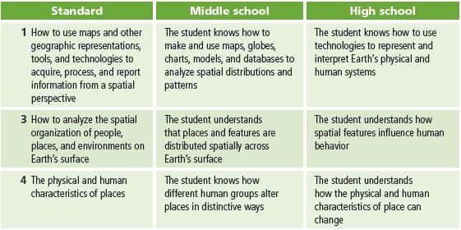

Teaching the lesson

Introducing the lesson
Begin by helping students understand that each map in a GIS has database information tied to it. In other words, a GIS map takes the numbers and words from databases and ties them to a location. The map shows patterns in the data we might not otherwise see.

The activity is structured on the geographic inquiry process. Read “Geographic inquiry and GIS” in the front section of the book to become familiar with this process. Introduce the lesson with “The geographic inquiry process” supplement. Have a brief discussion with your students about thinking geographically.

Student activity
We recommend that you complete the activity yourself before presenting the lesson in class. Doing so will allow you to modify the activity to accommodate the specific needs of your students. If they will not be working on individual computers be sure to explain any necessary modifications.
The following are things to look for while the students are working on this activity:
- Are students thinking spatially?
- Are students answering the questions?
- Are students using a variety of menus, buttons, and tools to answer the questions?
- Are students able to use the legends to interpret the data in the table of contents?

Concluding the lesson
Conduct a brief discussion in which you ask students to brainstorm ideas about how GIS can be used in everyday life or how they could use GIS in their daily school assignments or classes. Ask them to describe the geographic inquiry process as well as share how comfortable they are with using ArcGIS Online Map Viewer. This discussion should also include an overview of which buttons they have used, any ArcGIS Online Map Viewer operations that were confusing, and printer operations.
Middle school assessment. Students will have to create and print a map. They will be expected to turn on three layers and zoom in to a location of their choosing, use the Identify tool to obtain three pieces of data about that area, and write a brief paragraph explaining how they created their maps.
High school assessment. Students will have to create and print a map. They will be expected to turn on three layers and zoom in to a location of their choosing, use the Identify tool to obtain three pieces of data about that area, write a brief paragraph explaining how they created their maps, and describe what they learned geographically about the area on their map.

Extending the lesson
Challenge students to try the following:
- Create several maps with similar data.
- Calculate cell-phone density (the number of people per cell phone) using the World Phone Lines Mobile layer for 2015. Use maps and tables to explore how the use of mobile telephone technology may or may not have changed how a country develops its telephone landlines.
- Suggest other layers that might help explain the connections between telephone technology advances and sociopolitical issues like GDP, education, and health care.
- Develop a plan or outline for how to use GIS to fulfill a current class assignment.
- Choose a country in the news and use GIS skills to find the country and to study the data associated with it.

Answer key
Task 3: Work with layers
Q1) Which layers are turned on in the Contents and visible on the map? Large Cities, Rivers, Lakes, Countries

Task 5: Add a layer to your map
Q2) What makes this a geographic question? Answers will vary. Students should recognize that the question involves the distribution of something (phone lines) in different places (countries).
Q3) Write a hypothesis that answers the geographic question. The number of phone lines increases proportionately with the number of people in the world’s most populous countries. Or, the number of phone lines does not increase proportionately with the number of people.

Task 6: Add a layer to your map
Q4) What is the name of the layer that has been added to your table of contents? WorldCountriesPhone
Q5) Can you guess as to what data this layer has in it by its name? Students should guess information related to telephones and countries.

Task 7: Explore the World Phone Lines Land map
Q6) What color in the legend for the World Phone Lines Land layer indicates countries with the fewest phone lines? Light yellow or cream
Q7) What color indicates countries with the most phone lines? Dark rust
Q8) What color indicates countries with no data or “other” available for this layer? Gray
Q9) Does any other layer in your map have a graduated color legend? No
Q10) Which two countries have the most phone lines? China and the United States
Q11) On which continent are most of the countries with the fewest phone lines? Africa
Q12) Which two countries have the largest population? China and India
Q13) Name the five countries that are in the same population class (color) as the United States. Brazil, Indonesia, Nigeria, Pakistan, Bangladesh
Q14) Which of the five countries, if any, are in the same phone line class (color) as the United States? None of the countries
Q15) What two fields might help in answering the geographic question? POP2015, PHONLNS

Task 8: Investigate the relationship between phone lines and population in China
Q16) What was the population of China in 2015? Record the answer in the table below.

Q17) How many phone lines did China have in 2015? Record the answer in the table below.

Q18) What was the number of people per phone line in China? Record the answer in the table below.

Country | Population | Phone lines | People/phone line
China | 1,393,417,233 | 350,433,000 | 3.98

Task 9: Investigate the relationship between population and phone lines for all countries

Q19) For each country in the table below, what is the population, number of phone lines, and number of people per phone line? The first country, China, is already filled in for you.
Country | Population | Phone lines | People/phone line
China | 1,393,417,233 | 350,433,000 | 3.98
India | 1,273,629,594 | 49,750,000 | 25.60
United States | 322,592,787 | 268,000,000 | 1.20
Indonesia | 255,759,404 | 12,772,000 | 20.03
Brazil | 204,057,039 | 42,382,000 | 4.81
Pakistan | 196,493,215 | 5,162,798 | 38.06
Bangladesh | 175,082,263 | 1,070,000 | 163.63
Nigeria | 163,346,070 | 1,223,300 | 133.53

Task 10: Analyze the results of your research
Q20) In the table below, the column on the left ranks the countries by population from highest to lowest. In the column on the right, rank the countries from the lowest number of people per phone line to the highest number of people per phone line, using the data from Q19. Then draw lines connecting the name of each country in one column with the name of the same country in the other column.

Ranked by population  (highest to lowest) | Ranked by people/phone line  (lowest to highest)
China  India  United States  Indonesia  Brazil  Pakistan  Bangladesh  Nigeria | United States  China  Brazil  Indonesia  India  Pakistan  Nigeria  Bangladesh

Q21) Which country has the fewest people per phone line? United States
What is the number of people per phone line in this country? 1.20

Q22) How does the country in Q21 rank in population size among the eight countries in your table? It’s the third largest in population.
Q23) Which country has the most people per phone line? Bangladesh
What is the number of people per phone line in this country? 163.63
Q24) How does the country in Q23 rank in population size among the eight countries in your table? It’s the seventh largest in the top eight populated countries in the world.
Q25) What country has the most phone lines? China
How does the number of people per phone line in this country compare with the numbers of people per phone line in the seven other countries in your table? It is second.
Q26) Bangladesh and Pakistan are somewhat close in populatio. Why do you suppose these two countries have such different numbers of people per phone line?
What factors do you think contribute to this disparity? Possible answer: the countries have different cultures and different levels of economic development. (This is a good question to have students do more research on. Government and public incentives to the telecom industry in Bangladesh since 1989 spurred tremendous phone line implementation.)
Q27) What is the answer to the geographic question? The number of phone lines does not vary proportionately with population.
Q28) Compare your initial hypothesis (Q2) with your answer in Q27. How does your hypothesis compare with your answer to the geographic question? Answers will vary.

Task 10: Develop a plan of action
Q29) What country did you choose? ___________________________________________
Use the information in the table in Q20 to describe the phone line situation in your chosen country.
Possible answers:
China has the highest number of phone lines of any country in the world, but it has almost four times as many people (over one billion) as phone lines. Brazil also has almost five times as many people as phone lines; it ranks fifth in population among the eight countries, after the United States, India, Indonesia, and China.

Indonesia has 20.03 as many people as phone lines; it falls far behind other countries of similar size such as the United States (1.20 people per phone line) and Brazil (4.81 people per phone line).

The United States has 268 million phone lines—second-highest in the world; it leads the world in access to phone lines, with about as many phone lines as people.
Q30) Do you think that increasing the number of phone lines operating in your chosen country would improve the quality of life there? Why or why not?
Answers will vary
Q31) List three concerns you have about increasing the number of phone lines in your chosen country. Possible answers: cost, difficulty of providing access in rural areas or among the many islands of Indonesia, a preference for expanding more modern cell-phone infrastructure, or greater importance of other issues in the less developed countries (e.g., education, health care).
Q32) List two new geographic questions that you would like to investigate to help you develop a sound plan. Answers will vary but should include a geographic component.

This is a four-point rubric based on the National Standards for Geographic Education. The mastery level meets the target objective for grades 5–8.

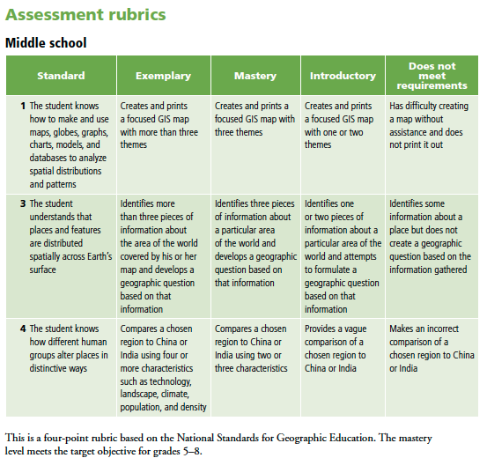

This is a four-point rubric based on the National Standards for Geographic Education. The mastery level meets the target objective for grades 9-12.

