Module 2, Lesson 2
Life on the edge

Lesson overview
Students will investigate the East Asia portion of the Ring of Fire, where millions of people live with the daily threat of significant seismic or volcanic events. They will identify zones of tectonic plate subduction and populations at risk.

Estimated time
Two to three 45-minute class periods

Materials
Internet access to arcgis.com
Student instruction
Student answer sheet
Student supplements
Student assessments
Colored pencils

Objectives
After completing the lesson, a student is able to do the following:
- Locate zones of significant earthquake and volcanic activities in East Asia
- Describe the relationship between zones of high earthquake or volcanic activity and tectonic plate boundaries
- Identify subduction zones along plate boundaries
- Identify densely populated areas that are most at risk for volcanic and/or seismic disaster

GIS tools and functions
- Identify a feature to learn more about it
- Zoom in on the map
- Measure distances between points on the map
- Add layers to the map
- Pan the map to view different areas
- Turn layers on and off

National Geography Standards
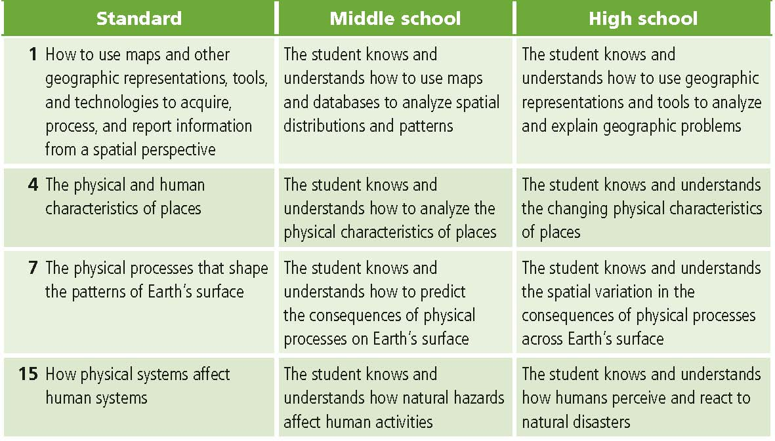Teaching the lesson

Introducing the lesson
Provide a brief overview of the region of East Asia and the Ring of Fire. Emphasize East Asia’s dense population. Ask students to draw on the Supplement map outlines of areas they believe to have the greatest risk for a major geophysical disaster. Allocate about 5 minutes for this task. Then, if time permits, ask some students to share their predictions with the class or divide students into small groups for discussion.

Student activity
We recommend that you complete the activity yourself before presenting the lesson in class. Doing so will allow you to modify the activity to accommodate the specific needs of your students. If they will not be working on individual computers, be sure to explain any necessary modifications. Students will analyze population density, plate boundaries, volcanoes, and earthquake activity for the years 2004 through mid-2007, and they will identify areas of subduction along plate boundaries. The following are things to look for when the students are working on this activity:
- Are the students answering the questions?
- Are the students referring to their original maps and notes from class discussion?
- Do some students complete the exercise quickly? If yes, refer to “Extending the lesson” for additional challenges.

Concluding the lesson
Lead a class discussion comparing student predictions of disaster-prone areas (Supplement) and their findings from the investigation. How closely did their predictions match what they learned?

Assessment. Students are asked to mark zones at risk for volcanic and seismic events on a paper map, to create a legend, and to analyze the map.
After students complete the assessment, you may want to solicit additional discussion:
- Have students identify what data was most important in determining risk zones in the assessment. One way to do this is to list types of data on the board and have the students rank them in order of importance.
- Discuss why some data was more helpful than other data.
- Ask students if there is other data that they think would be helpful and to explain why.

Extending the lesson
Challenge students to try the following:
- Analyze historical data for the most notable earthquakes and volcanic eruptions, create new layers from this data, and make predictions on the next significant eruption or seismic event for East Asia.
- Research and report on a recent earthquake and its effects.
- Mark the earthquake location on the map using the Draw tools and create a map using the map document and data from this lesson to illustrate the report.
- Add or create a new layer showing locations of natural hazards in your local area.
- Present their maps to the class, comparing their predictions on Supplement maps to the results of their analysis on Assessment maps.
Check out the “Resources by Module” section of this book’s Web site—www.esri.com/ourworldgis education—for print, media, and Internet resources on the topics of earthquakes, volcanoes, plate tectonics, and East Asia.

Answer key
Task 1: Open a map document and identify cities
Q1. Use the Identify tool to locate one city within each country listed in the table below and record that city’s population. Possible answers are listed in the table. 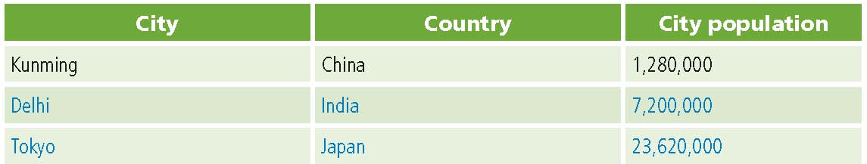
Task 2: Look at population density and earthquake magnitudes
Q2. Use the Identify tool to locate two East Asian cities in areas where population density is greater than 250 people per square kilometer. Possible answers: Nanjing, China; Calcutta, India
Q3. Describe the general pattern of population density in East Asia. Areas of high population density are found in the southeastern part of the region. Specific areas students may mention include eastern China, the Indian subcontinent, southeast Asia peninsula, Japan, and some islands. The remainder of East Asia has generally low population density.
Q4. In general, where did earthquakes with a magnitude of ≥5 occur? Answers will vary but should mention that many of the earthquakes occurred along the islands of the Pacific Rim, with some occurring under the ocean.
Q5. Did these earthquakes occur near densely populated areas? Where? Yes: Japan, Indonesia, Philippines, Taiwan

Task 3: Measure the distance between active volcanoes and nearby cities
Q6. What is the closest distance you found between an active volcano and a city? Record that city, the volcano, and the distance between them. Possible answer: City: Manado, Indonesia. Volcano: Mahawu. Distance: 7 kilometers
Q7. Are there many active volcanoes located close to cities? Yes
Q8. What patterns do you see in the locations of volcanoes, and how do they compare with the earthquake patterns? The patterns of earthquake and volcano locations are virtually the same, especially along the islands of the Pacific Rim (the western edge of the Ring of Fire).

Task 4: Look at plate boundaries
Q9. Record labels on the Supplement map. Refer to the Region2 map document for correct answers.

Task 5: Add an image file
Q10. On the Supplement map, draw the zones of subduction. Student maps should indicate subduction zones along the western boundary of the Pacific plate and the eastern and southern boundaries of the Indo-China plate.

Task 6: Investigate your map
Q11. Record the name of the plate you investigated. List three cities and three physical features in the vicinity. Possible answers are listed below.

Plate name: Amur Plate
Cities:
1. Nagoya, Japan
2. Pusan, South Korea
3. Vladivostok, Russia
Physical features:
1. Fuji-san (volcano)
2. Haku san (volcano)
3. Ocean trench at southern boundary

Assessment rubrics
Middle School
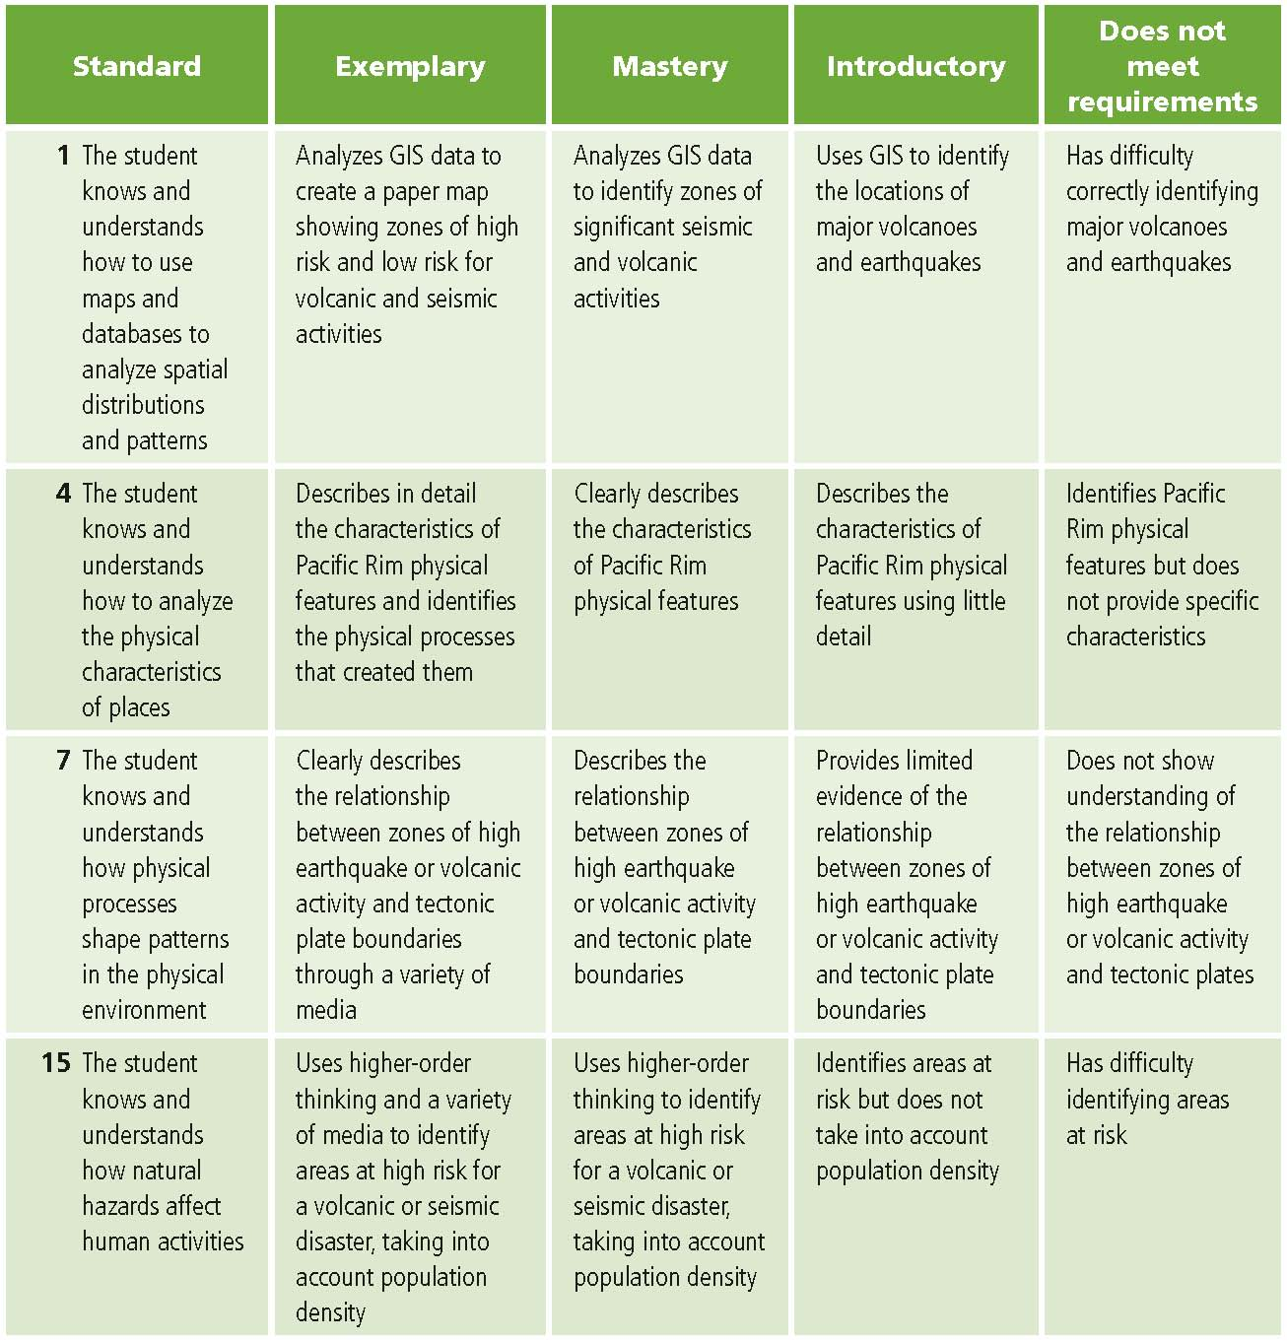This is a four-point rubric based on the National Standards for Geographic Education. The mastery level meets the target objective for grades 5–8.

High school
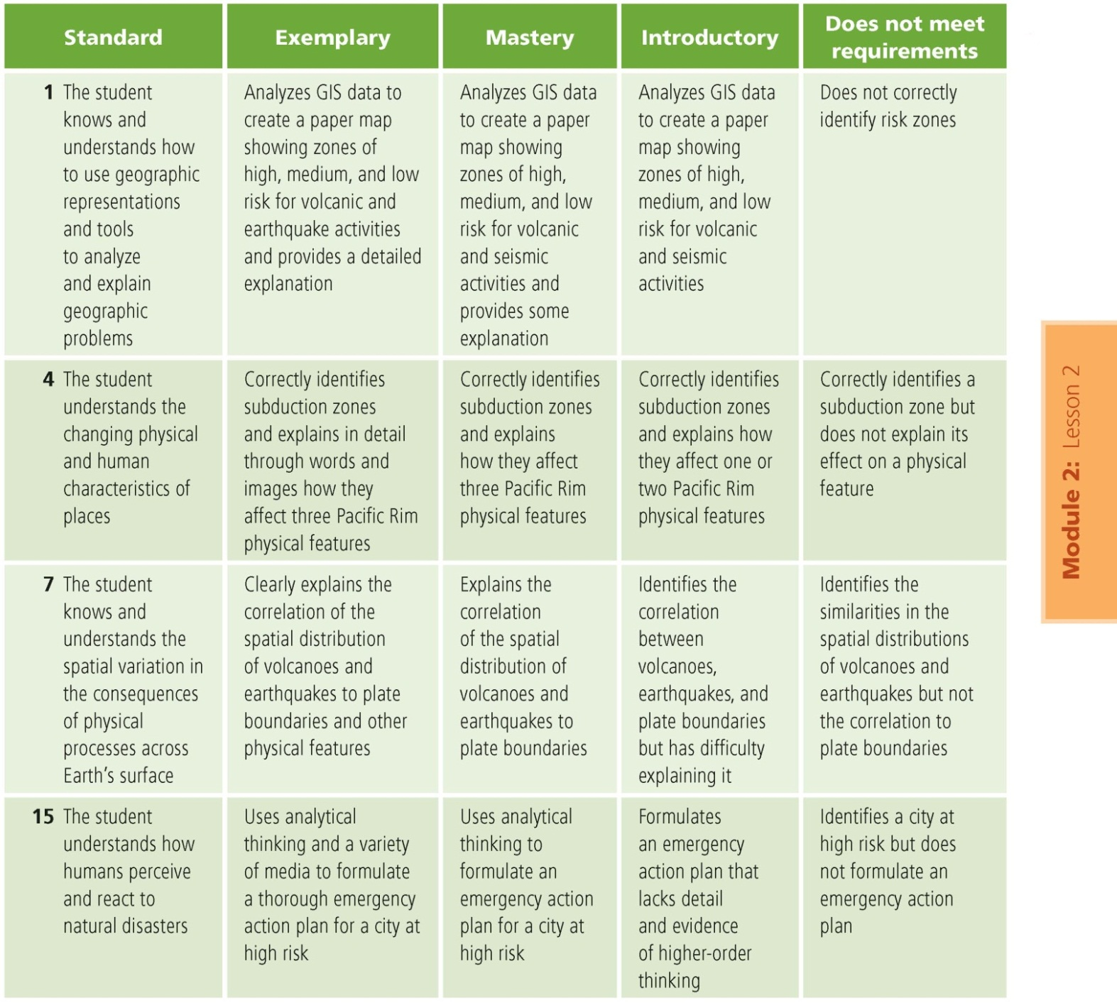This is a four-point rubric based on the National Standards for Geographic Education. The mastery level meets the target objective for grades 9–12.

