Module 7, Lesson 2
In the eye of the storm
A regional investigation of Central America

Lesson overview
Students will study Hurricane Mitch, the deadliest storm of the twentieth century, and the havoc it wreaked on several Central American countries. They will analyze information about the storm itself and about the region before the storm, and they will consider the storm’s consequences.

Estimated time
Two 45-minute class periods

Materials
- Internet access to arcgis.com
- Student Instructions document
- Student answer sheet document
- Student assessments

Objectives
After completing this lesson, a student is able to do the following:
- Analyze regional features vulnerable to natural disasters
- Follow the development and impact of a major hurricane
- Integrate satellite imagery of a hurricane with a plot of the hurricane’s path

GIS tools and functions
- Zoom in and out of the map
- Add layers to the map
- Move the map to bring a different portion of it into view
- Measure distance
- Turn layers on and off

National Geography Standards
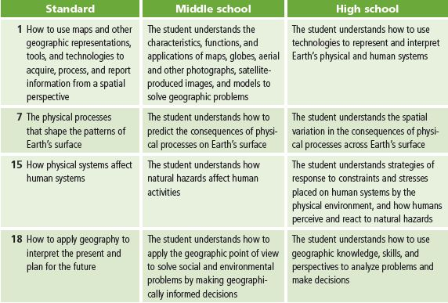

Teaching the lesson

Introducing the lesson
Begin the lesson by discussing the weather hazards of your own region. Use the following questions as a guide:
- What weather hazards are specific to our hometown or region?
- When do they typically occur—year-round or in a particular season?
- What are some characteristics of these phenomena?
- How do you prepare for one? You may want to review school procedures or have the students share plans they have from home.

After the discussion, tell your class that in this activity they will be studying the impact of Hurricane Mitch on a large area of Central America. They will explore characteristics of the storm and how it affected the region. In the final assessment, they will be part of a special team developing an action plan for dealing with the devastation the storm caused.

Student activity

We recommend that you complete the activity yourself before presenting the lesson in class. Doing so will allow you to modify the activity to accommodate the specific needs of your students. If they will not be working on individual computers, be sure to explain any necessary modifications.

The following are things to look for while the students are working on this activity:
- Are the students using a variety of tools?
- Are the students answering the questions?
- Are the students beginning to ask their own questions?

Concluding the lesson
Have students share their findings, either in small groups or as a class. They should have a basic understanding of the region and the effect of the storm in terms of rainfall amounts, wind speeds, and so forth. Ask your students which parts of the region suffered the most damage and why.

Encourage students to do their own research while completing the assessment. The U.S. Geological
Survey has a large amount of data at http://mitchnts1.cr.usgs.gov on the impact of Hurricane Mitch and disaster recovery efforts in the affected countries. Allow class time for each team to meet and plan how they will complete the assessment.

Assessment
Students are asked to predict damage from Hurricane Mitch and to develop a disaster relief plan. Assign students to teams of three or four. Each team should have a leader, a cartographer, and a data expert. Teams of four can also have a multimedia specialist responsible for creating a presentation of the team’s findings. Assign each team to deal with either flood hazards or volcano and landslide hazards in a particular country. Students can present their results orally or in writing.

Extending the lesson
Challenge students to do the following:
- Do research to find out what disaster relief plans might exist for your city using a local natural hazard as the potential threat.
- Research past disasters in your city or region to find out how they affected the local area.
- Watch excerpts from the films The Perfect Storm or Twister and discuss how these fictional storms relate to real ones.
- Do a book report on Isaac’s Storm, by Erik Larson, and compare the Galveston storm of 1900 to Hurricane Mitch.
Answer key
Step 2: Identify the capital cities of Central America
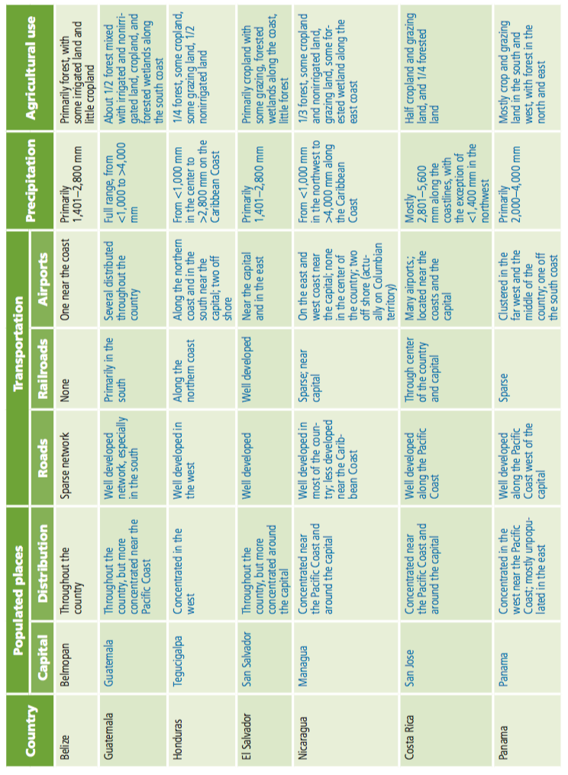
Q1. Record the capitals of Central American countries in the table below. Possible answers are listed in the table.

Step 3: Investigate Central America prior to Hurricane Mitch
Q2. Fill in the Populated places Distribution column and the three Transportation columns in the table in Q1. Possible answers are listed in the table.
Q3. Analyze the annual precipitation for each country and fill in the Precipitation column in the table in Q1. Possible answers are listed in the table.
Q4. Fill in the last column in the table in Q1. Possible answers are listed in the table.
Q5. Which country has the largest proportion of its area devoted to crops? El Salvador
Q6. Which country is the most mountainous? Honduras
Q7. Which country has the largest proportion of its territory covered by roads? El Salvador
Step 4: Track Hurricane Mitch
Q8. When was Tropical Storm Mitch at this location? 10/22/21Z, or 9 pm on the twenty-second of October
Q9. What was Mitch’s wind speed at this location? 40 mph
Q10. What are the latitude and longitude coordinates for Hurricane Mitch at this location? 14.3 latitude, –77.7 longitude
Q11. When was Hurricane Mitch at this location? 10/24/09Z, or 9 am on the twenty-fourth of October
Q12. What was Mitch’s wind speed at this location? 80 mph
Q13. When was Hurricane Mitch at this location? 10/27/21Z, or 9 pm on the twenty-seventh of October
Q14. What was Mitch’s wind speed at this location? 135 mph
Q15. How long did it take for Tropical Storm Mitch to become a category 5 hurricane? Hurricane – 5 time point: 10/26/12Z Tropical_Storm time point: 10/24/03Z Time difference: 00/02/09, or 2 days and 9 hours
Q16. What was Hurricane Mitch’s maximum wind speed during this period? 155 mph
Step 5: Measure the size of the storm
Q17. What is the diameter of the eye of Hurricane Mitch? About 25 miles

Q18. Fill in the first row in the table on the following page. Approximate answers are listed in the table.
Image | Distance (miles) |  |  | Change from previous image
 | Diameter of the eye | Diameter of the storm | Between the eye and the coastline of Honduras
Mitch2 Satellite Image | 25 | 830 | 110 | –––––––––––––––––––––
Mitch3 Satellite Image | 13 | 1000 | 50 | Storm appears more intense and enlarged. It’s closer to the coastline.
Mitch4 Satellite Image | 0 (not visible) | 830 | 0 (on shore) | The eye is not visible, clouds are much thicker, but the spiral shape is still visible.
Mitch5 Satellite Image | 0 (not visible) | 880 | 0 (on shore) | The cloud area is still large, but the spiral shape is gone.

Q19. Fill in the rest of the table above. Approximate answers are listed in the table.
Q20. What pattern do you notice in the amount of rainfall? The greatest amount of precipitation is on the southwest arm of the storm.
Q21. Is this a pattern you expected to find? Why or why not? Answers will vary.
Q22. What is the highest range of rainfall in the Rain4 layer? 24–29 inches
Q23. Which country received the majority of this heavy rain? Nicaragua
Q24. Describe the difference between the rainfall patterns on October 30 (Rain4 layer) and October 31 (Rain5 layer). The heaviest rainfall on October 30 was centered over the western coast of Nicaragua and southern El Salvador, with other rain bands extending due north and one off the eastern coast of Nicaragua and Honduras. On October 31, the main rain center was less intense. The outside bands appear to have merged with the main rain band from October 30.
Q25. What kind of damage do you expect to find with this type of storm? What aspects of the region will be most affected? Use the table in Q1 as a resource. Answers will vary and can mention flooding, landslides, damaged utility lines, washed out roads, destroyed crops, etc

