Module 2, Lesson 1
The earth moves
A global perspective

Lesson overview
Students will observe seismic and volcanic activity patterns around the world, analyze the relationships of those patterns to tectonic plate boundaries and physical features on the earth’s surface, and identify cities at risk.

Estimated time
Two 45-minute class periods

Materials
The student worksheet files can be found on the Data and Resources CD. Install the teacher resources folder on your computer to access them.
- Internet access to arcgis.com
- Student Activity
- Student answer sheet
- Student supplements
- Large wall map of the world
- 100 adhesive dots or map pins in two colors
- Colored pins

Objectives
After completing the lesson, a student is able to do the following:
- Locate zones of significant seismic or volcanic activity
- Describe the relationship between zones of high seismic or volcanic activity and tectonic plate boundaries
- Identify cities threatened by earthquakes or volcanic eruptions

GIS Tools and Functions
- Turn layers on and off
- Zoom to the full extent of the map
- Browse up one level
- Open the attribute table for a layer
- Sort data in ascending or descending order
- Zoom and pan the map using the mouse

National Geography Standards 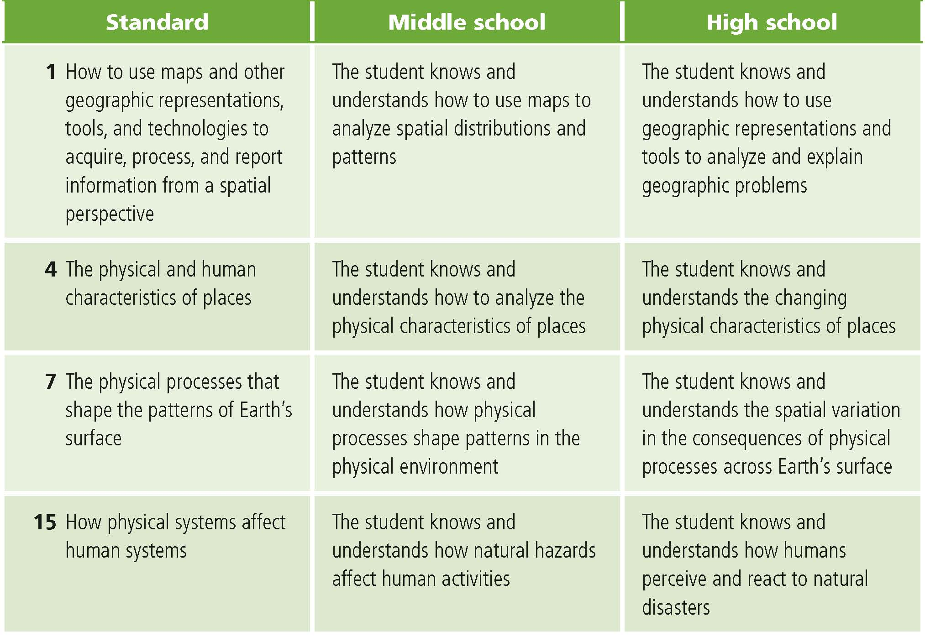

Teaching the lesson

Introducing the lesson
Have students mark with the letters V and E eight locations on the Supplement map where they believe volcanoes are located and eight locations where they think earthquakes typically occur. Once students have done this individually, have them discuss their ideas in groups of three or four, answer the questions in the Supplement as a group, and choose five volcano locations and five earthquake locations to mark on the large class map. (Use one color for earthquakes and the other for volcanoes.) After all the groups have marked their selections with adhesive dots or map pins, briefly discuss the patterns on the map.

Student activity
We recommend that you complete the activity yourself before presenting the lesson in class. Doing so will allow you to modify the activity to accommodate the specific needs of your students. If they will not be working on individual computers, be sure to explain any necessary modifications.

Students will use GIS to identify zones of volcanic and seismic activity and cities at risk.
- The following are things to look for while the students are working on this activity:
- Are the students using a variety of tools?
- Are the students answering the questions?
- Are the students referring to their original maps and notes from group discussion?

Concluding the lesson
Engage students in a discussion of the observations and discoveries that they made during their exploration of the maps. Ask students to compare their initial ideas—as reflected by the pattern of colored dots on the class wall map—with the insights they acquired in the course of the activity. How have their ideas about earthquakes and volcanoes changed since the start of the lesson? Has this lesson raised any questions that they would like to explore further? How can GIS help world cities better prepare for seismic and volcanic events?

Middle school assessment. Students are asked to mark plate boundaries, physical features, and cities at risk on a paper map; to describe the relationships between plate boundaries and areas of frequent earthquake or volcanic activity; and reflect on their selections of cities at risk.

High school assessment. Students are asked to mark plate boundaries, physical features, and cities at risk on a paper map; to research a city’s disaster preparedness plan; and to hypothesize on how selected physical features were created.

Extending the lesson
Challenge students to try the following:
- Explore the natural hazards in your region.
- Explore the hazards data included.
- Look at historical data for notable earthquakes and volcanic eruptions, incorporate this data as new layers, and predict the next significant eruption or seismic event
- Analyze fault line data included with this lesson to see if it provides additional insight on locations and movement of plate boundaries

See the “Resources by Module” section of this book’s Web site - www.esri.com/ourworldgiseducation - for print, media, and Internet

Answer Key
Task 2: Analyze earthquake locations
Q1. Do earthquakes occur in the places you predicted? List the regions you predicted correctly for earthquake locations. Answers will vary depending on student predictions.

Q2. What patterns do you see on the map? Answers will vary and can include that many earthquakes occur on the western coast of North and South America, along the eastern coast of Asia, and along the islands of the Pacific Rim. The pattern follows the Ring of Fire. They may also note a pattern of earthquakes down the center of the Atlantic Ocean and a string in the southern Atlantic, from South America eastward through to the Indian Ocean. Another string runs east and west through south-central Asia and southern Europe.

Task 3: Sort and analyze earthquake magnitudes
Q3. How do the 20 selected locations compare to your map in supplement A? List three ways. Answers will vary depending on student predictions. If students selected any spots around the Ring of Fire, then their predictions were close to reality.

Task 4: Analyze volcano data
Q4. How do the volcano locations compare with your original predictions? List the regions of volcanic activity you predicted correctly. Answers will vary depending on student predictions. If students selected any spots around the Ring of Fire, then their predictions were close to reality.
Q5. What patterns do you see in the volcano locations, and how do they compare with the earthquake patterns? The earthquake and volcano locations line up in similar patterns with the exception of the volcanoes in some areas of Africa.

Q6. Formulate a hypothesis as to why volcano eruptions and earthquakes happen where they do.
Answers will vary but should allude to the idea of plate tectonics and the fact that move
ment at plate boundaries causes disruptions on the earth’s surface.

Task 5: Identify active volcanoes on different continents
Q7. Click on active volcanoes in green to find the names, elevations, and countries of three active volcanoes. Click the More Info link to get more data.
Possible answers: Banahao, 2,177 m, Philippines; Ibu, 1,340 m, Indonesia; Haku San,
2,702 m, Japan.

Task 6: Plate boundaries and physical features
Q8. Based on the locations of earthquakes and volcanoes, where do you think the plate boundaries are? Draw them on the Supplement map. Answers will vary.

Q9. Compare the actual plate boundaries to the ones you drew on the Supplement map. Record all similarities and differences. Answers will vary based on students’ original hypotheses. If students drew the boundaries to follow the patterns of earthquakes and volcanoes, then they are on target.

Q10. Are there any areas where physical features, plate boundaries, and seismic and volcanic activities overlap? Answers may include the eastern part of the map where the Philippine and Pacific plates meet, eastern Africa, the Mid-Atlantic Ridge, and the western coast of North and South America.

Q11. Write the names of physical features in the first column of the table below and label them on the Supplement map. Possible answers are listed in the table.

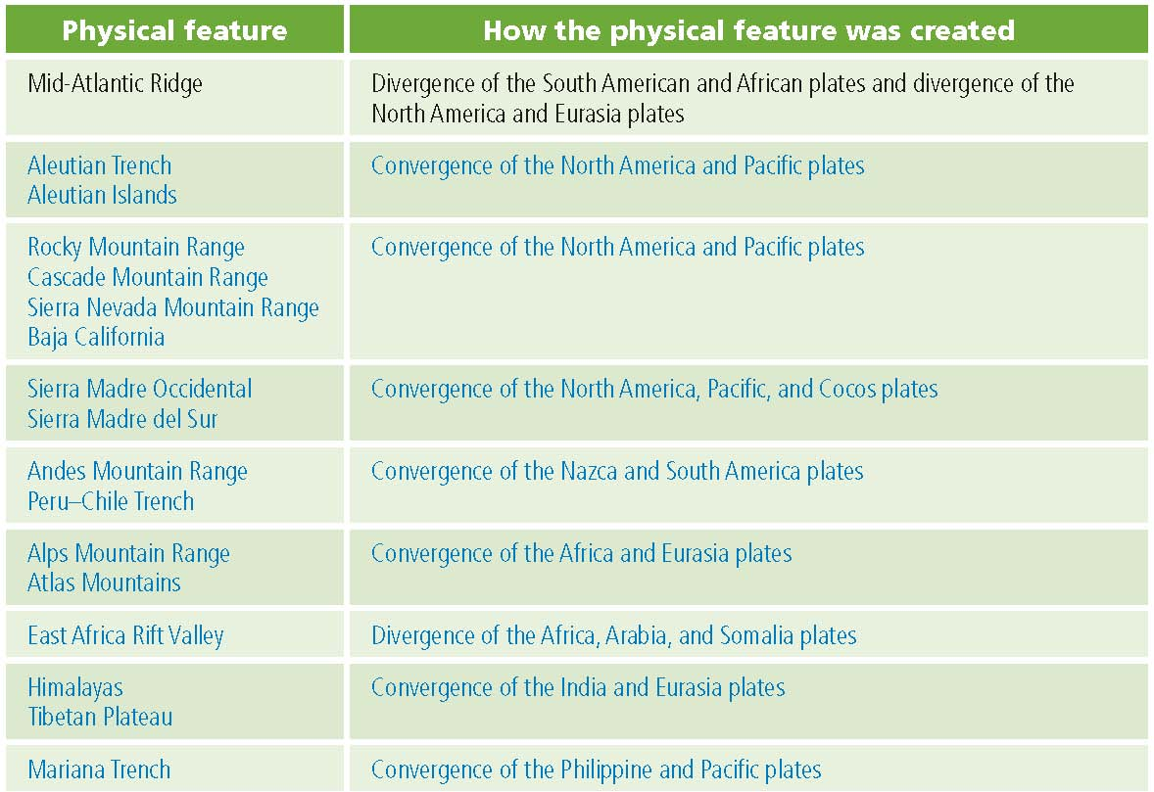

Q12. In the second column of the table above, write how you think each physical feature was created. Possible answers are listed in the table. Students can find additional physical features by consulting an atlas or a physical map of the world.

Q13. List five high-risk cities and five low-risk cities. Possible answers are listed below.

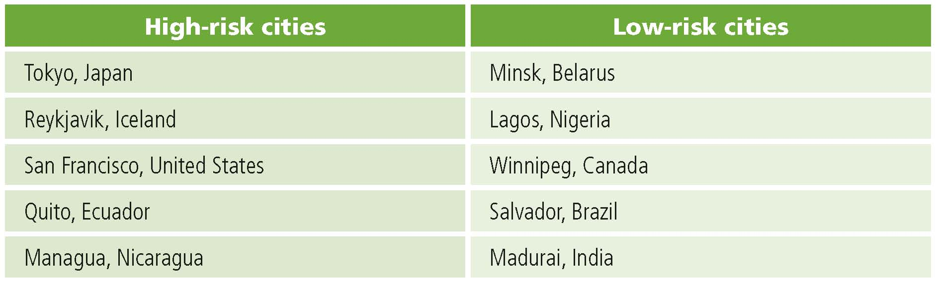

This is a four-point rubric based on the National Standards for Geographic Education. The mastery level meets the target objective for grades 5–8.

Middle school 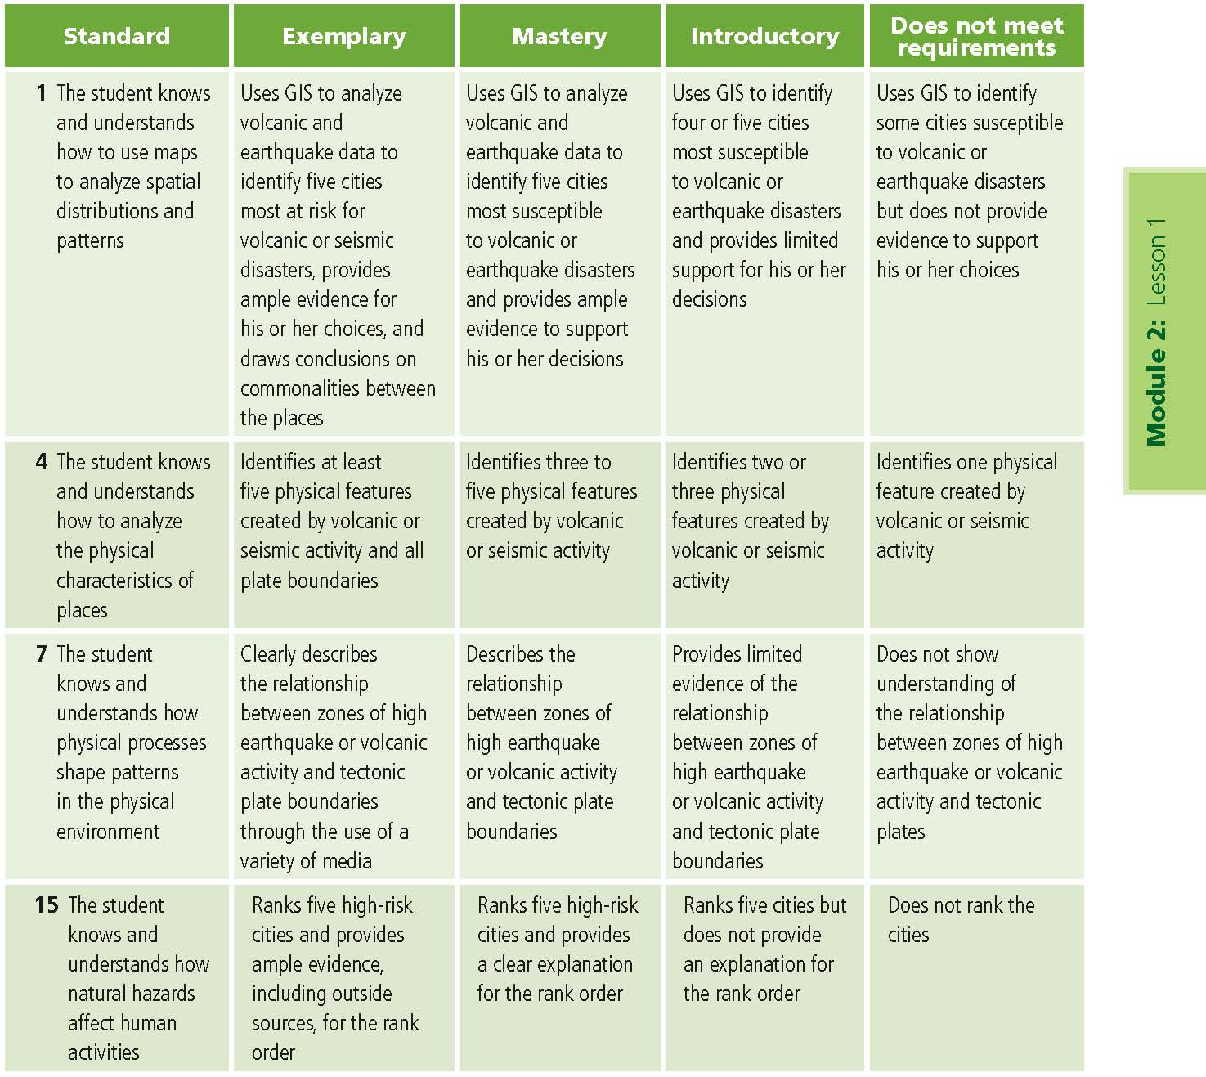

This is a four-point rubric based on the National Standards for Geographic Education. The mastery level meets the target objective for grades 9–12.

